**Building a Piano with Micro:Bit**

**The Hook-Up**

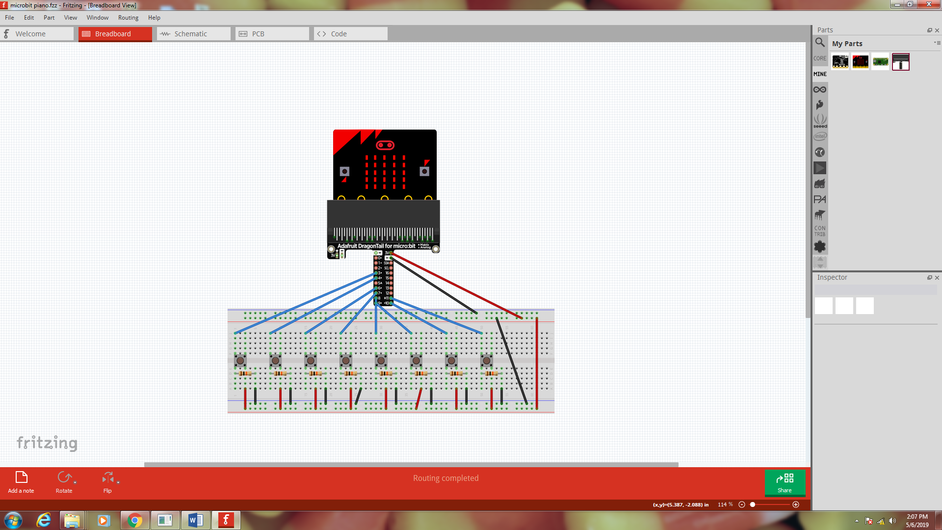

**Theory**

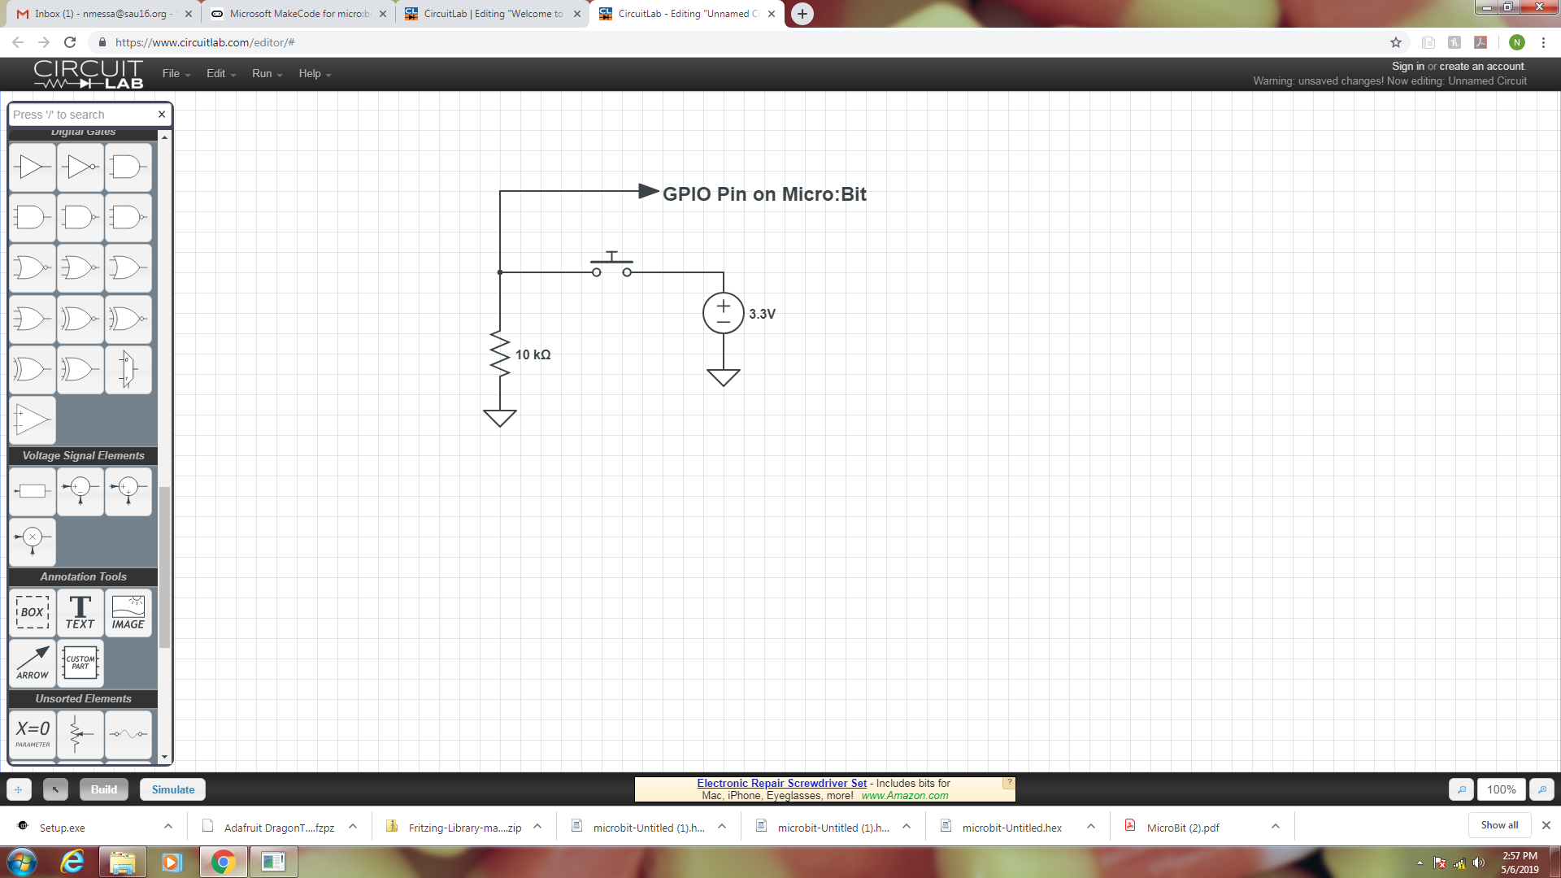Pushbutton switches are connect as shown. One side of the switch is connected to 3.3 V on the Micro:Bit and the other side of the switch is connected to ground via a 10K Ω resistor. When the switch is open, the GPIO (General Purpose Input Output) is at 0 V (logic 0). When the switch is pushed, the GPIO pin is at 3.3 V (logic 1). The Micro:Bit has 17 GPIO Pins. They are pin 0 to 16. Many of these pins are shared with other devices however a few are dedicated GPIO (pins 8 and 12). Pin 5 is shared with button A and is connected to 3.3 V so detect an external button push, it must be pulled down to 0 V.

**The Code**

